|  |
| --- |
| BLACK FRIDAY SALES |
| TEAM NAME: FOUR PIES |
| TEAM MEMBERS: M MADHAN  T MADHAVA KRISHNA  D C H N PHANEENDRA  P MANOJ |
|  |
|  |



Topic .

1. Title of the project
   1. Introduction
   2. Objectives of research
   3. Problem Statement
   4. Industry Profile

1. Review of literature
2. Data Collection
3. Methodology
   1. Exploratory Data Analysis

4.1.1 Figures and tables

* 1. Statistical Techniques and Data Visualization
  2. Data Modeling using Supervised ML techniques

1. Findings and Suggestion
2. Conclusion
3. References

Chapter-1:

INTRODUCTION:

The first recorded use of the term “**Black Friday**” was applied not to holiday shopping but to financial crisis: specifically, the crash of the U.S. gold market on September 24, 1869.

Black Friday is an informal name used to describe the day after Thanksgiving. It's traditionally the busiest shopping day of the year because it kicks off the holiday season. This season is crucial for the economy because around [30 percent of annual retail sales occur during the holiday season](https://nrf.com/sites/default/files/2015%20NRF%20HSK_102015_Final.pdf). For some retailers, such as jewelers, it's even higher, at almost 40 percent.

HISTORY:

**Black Friday Sales Statistics**

**Thanksgiving and Black Friday are still the busiest shopping days for stores, but traffic is declining.** In 2018, it fell [as much as 9 percent](https://www.wsj.com/articles/store-traffic-falls-again-on-black-friday-but-not-all-news-is-bad-1543165988?mod=djem10point) from 2017. The [number of people visiting stores](https://www.wsj.com/articles/inside-the-wal-mart-vs-amazon-battle-over-black-friday-1511733478?mod=djem10point) in 2017 was 4 percent lower than in 2016. RetailNext Inc. analyzed in-store videos to count the shoppers.

In 2016, there were 101.7 million people who braved the crowds. That's more than the 74 million in 2015. The next biggest day was Saturday when 64 million people went to stores. Only 33 million shopped on Sunday. The fewest, 29 million, left their homes on  **Thanksgiving Day 2016**. In total, 137 million people went to stores over the **four-day Black Friday weekend** in 2016. That's a third more than the 102 million in 2015.

More people went online since stores put their best deals on their websites. Online sales for Wednesday through Black Friday was 26.4 percent higher than in 2017, estimated [Adobe Systems](https://www.digitalcommerce360.com/2018/11/23/thanksgiving-and-black-friday-online-sales-are-blowing-past-expectations/). In 2017, online sales were up 18 percent.

**Holiday Season Sales Statistics**

Black Friday is part of the **holiday shopping season**. That includes November and December,[according to the National Retail Federation](https://nrf.com/media/press-releases/consumers-will-spend-41-percent-more-last-year-during-winter-holidays-according) (NRF). The NRF forecasts that sales will be up 4.1 percent in 2018. It doesn't expect the trade war to cut back on sales because retailers stocked up on inventory. Otherwise, the tariffs would increase on most consumer goods imported from China.

Early reports from [Mastercard SpendingPulse](https://www.wsj.com/articles/u-s-holiday-retail-sales-are-strongest-in-years-early-data-show-11545777668?mod=djem10point) saw total sales, excluding automobiles, up 5.1 percent between November 1 and December 24 from the prior year. Consumers spent $850 billion. Online shopping grew 19.1 percent during that period.

On average, shoppers expect to spend $1,007.24 each. Of that, they'll spend $637.67 on gifts. Another $215.04 will go for food, decorations, flowers, and greeting cards. They'll also spend $154.53 to take advantage of the seasonal deals and promotions.

Here are the past 15 years of [retail sales](https://www.thebalance.com/u-s-retail-sales-statistics-and-trends-3305717) data. The average annual increase is 2.5 percent, thanks to the steep 4.6 percent decline in 2008. Before the [2008 financial crisis](https://www.thebalance.com/2008-financial-crisis-3305679), the 10-year average annual increase was 3.5 percent.

| **Year** | **Spent per Shopper** | **Total Spent** | **Percent Increase** |
| --- | --- | --- | --- |
| **2002** | N.A. | $416.4 billion | 2.1% |
| **2003** | N.A. | $437.6 billion | 5.1% |
| **2004** | N.A. | $467.2 billion | 6.8% |
| **2005** | $734.69 | $496.2 billion | 6.2% |
| **2006** | $750.70 | $512.6 billion | 3.2% |
| **2007** | $755.13 | $525.9 billion | 2.7% |
| **2008** | $694.19 | $501.7 billion | -4.6% |
| **2009** | $681.83 | $503.2 billion | 0.2% |
| **2010** | $718.98 | $529.4 billion | 5.2% |
| **2011** | $740.57 | $553.8 billion | 4.6% |
| **2012** | $752.24 | $568.7 billion | 2.6% |
| **2013** | $767.24 | $584.1 billion | 2.9% |
| **2014** | $802.45 | $608.0 billion | 5.0% |
| **2015** | $805.65 | $626.1 billion | 3.2% |
| **2016** | $935.58 | $655.8 billion | 3.6% |
| **2017** | $967.13 | $682.0 billion | 4.0% |
| **2018** | $1,007.24 | $717.5 billion | 4.3% |

### Black Friday Hiring

The NRF survey reported that stores would hire between 500,000 and 550,000 seasonal workers in 2017. That's fewer than the record 764,750 workers hired in 2013. At least it's not as bad as the 263,820 workers hired in 2008.

OBJECTIVES:

To Predict customer purchases on Black Friday using Random Forest Regreesion

To visualize the flow of the sales that are purchased on the Black Friday

To get the reguired graphs and Tables from the given dataset

Chapter-2:

PROBLEM STATEMENT:

We are estimating the sales during the Black Friday.We can predict the purchase records of the sales that are going to be sold on the Black Friday and predicting the purchase values.

INDUSTRY PROFILE:

Black Friday has two relevant meanings. In history, Black Friday was a [stock market](https://www.investopedia.com/terms/s/stockmarket.asp) catastrophe that took place on Sept. 24, 1869. On that day, after a period of rampant [speculation](https://www.investopedia.com/terms/s/speculation.asp), the price of gold plummeted, and the markets crashed.

But the more contemporary meaning refers to the day after the U.S. Thanksgiving holiday, which has also traditionally been a holiday itself for many employees. It is typically a day full of special shopping deals and heavy discounts and is considered as the kickoff of the holiday shopping season.

Volume 0%

01:32

01:32

#### Black Friday

### Understanding Black Friday

It's common for retailers to offer special promotions and open their doors during the pre-dawn hours on Black Friday to attract customers. To keep up with the competition, some retailers have gone so far as to keep their operations going on the Thanksgiving holiday, while others begin offering deals earlier during November.

Really avid bargain-hunters have been known to camp out overnight on Thanksgiving to secure a place in line at a favorite store; the most fanatical have been known to skip Thanksgiving dinner altogether and camp out in parking lots for days or even weeks to get great deals. The promotions usually continue through Sunday, and traditional [brick-and-mortar](https://www.investopedia.com/terms/b/brickandmortar.asp) stores see a spike in sales.

### Black Friday and Retail Spending

Retailers may spend an entire year planning their Black Friday sales. They use the day as an opportunity to offer rock-bottom prices on overstock [inventory](https://www.investopedia.com/terms/i/inventory.asp) and to offer [doorbusters](https://www.investopedia.com/terms/d/doorbuster.asp) and discounts on seasonal items, such as holiday decorations and typical holiday gifts. Retailers also offer significant discounts on big-ticket items and top-selling brands of TVs, smart devices and other electronics, luring customers in the hope that, once inside, they will purchase higher-[margin](https://www.investopedia.com/terms/p/profitmargin.asp) [goods](https://www.investopedia.com/terms/c/consumer-goods.asp). The contents of Black Friday advertisements are often so highly anticipated that retailers go to great lengths to ensure that they don't leak out publicly beforehand.

Consumers often shop on Black Friday for the hottest trending items, which can lead to stampedes and violence in the absence of adequate security. For example, on Black Friday in 1983, customers engaged in scuffles, fistfights, and stampedes in stores across the U.S. to buy Cabbage Patch Kids dolls, that year's must-have toy, which was also believed to be in short supply. Appallingly, a worker at a big store was even trampled to death on Black Friday in 2013, as throngs of shoppers pushed their way into the store when the doors opened.

### The Surprising Origins of Black Friday

The concept of retailers throwing post-Turkey Day sales started long before the day was actually coined "Black Friday.” In an effort to kick off the holiday shopping season with a bang and attract hordes of shoppers, stores have promoted major deals the day after Thanksgiving for decades, banking on the fact that many companies and businesses gave employees that Friday off.

So why the name? Some say the day is called "Black Friday" in homage to the term "black" referring to being profitable, which stems from the old bookkeeping practice of recording [profits](https://www.investopedia.com/terms/p/profit.asp) in black ink and losses in red ink. The idea is retail businesses sell enough on this Friday (and the ensuing weekend) to put themselves "in the black” for the rest of the year.

However, long before it started appearing in advertisements and commercials, the term was actually coined by overworked Philadelphia police officers. In the 1950s, crowds of shoppers and visitors flooded the City of Brotherly Love the day after Thanksgiving. Not only did Philadelphia stores tout major sales and the unveiling of holiday decorations on this special day, but the city also hosted the Army/Navy football game on Saturday of the same weekend. As a result, traffic cops were required to work 12-hour shifts to deal with the throngs of drivers and pedestrians, and they were not allowed to take the day off. Over time, the annoyed officers started to refer to this dreaded workday as "Black Friday."

The term quickly gained popularity and spread to store salespeople who used "Black Friday” to describe the long lines and general chaos they had to deal with on that day. It remained Philadelphia’s little inside joke for a few decades, although it spread to a few nearby cities, such as Trenton, New Jersey. Finally, in the mid-1990s, "Black Friday” swept the nation and started to appear in print and TV ad campaigns across the United States.

### The Evolution of Black Friday

Somewhere along the way, Black Friday made the giant leap from congested streets and crowded stores to fevered shoppers fighting over parking spaces and pepper-spraying each other tussling over the last Tickle Me Elmo. When did Black Friday become the frenzied, over-the-top shopping event it is today?

That would be in the 2000s when Black Friday was officially designated the biggest shopping day of the year. Until then, that title had gone to the Saturday before Christmas. Yet, as more and more retailers started touting "can’t miss” post-Thanksgiving sales, and the Black Friday discounts grew deeper and deeper, American consumers could no longer resist the pull of this magical shopping day.

Today, Black Friday is becoming an increasingly lengthy event – a Black Weekend. In 2013, Target announced that instead of opening its doors on Friday morning, it would start sales on Thanksgiving evening. That started a frenzy across major retailers: Best Buy, Kmart, Walmart, and Macy’s quickly followed suit. However, adding a shopping day only seems to increase sales by 1 percent to 2 percent, according to ShopperTrak, a site dedicated to analyzing consumer spending behavior.

It turns out that as Thanksgiving Day sales are growing rapidly, Black Friday sales are decreasing at just about the same pace. The primary benefit of opening on Thanksgiving: fewer shoppers out on Black Friday helping to keep the crowds smaller and the lines shorter. Still, Friday remains the busiest day, by far, of the holiday weekend.

### Shopping Stats

Residents of the Southern states typically spend more than those in the North. The state of Texas, and even more precisely the city of Austin, is home to the biggest spenders in the country. Other cities housing serious shoppers are Scottsdale, Arizona, and San Jose, California. States with a higher [cost of living](https://www.investopedia.com/terms/c/cost-of-living.asp), such as Connecticut, Hawaii, and California, also tend to see larger [expenditures](https://www.investopedia.com/terms/c/capitalexpenditure.asp).

Statistics show that men are more likely to shop on Black Friday than women, and to spend an average of 3 percent more. Statistically, age also factors into holiday spending, with those in the 50- to 65-year bracket spending nearly 75 percent more than those ages 18 to 25. According to the NRF, clothing, and accessories account for more than half of purchases made during Black Friday weekend.

### The Significance of Black Friday

With people spending rather hefty sums of money on this notoriously busy shopping day, the sales chalked up on Black Friday are often thought of as a litmus test for the overall economic condition of the country and a way for [economists](https://www.investopedia.com/terms/e/economist.asp) to measure the confidence of the average American when it comes to [discretionary spending](https://www.investopedia.com/terms/d/discretionary-expense.asp). Those who share the [Keynesian](https://www.investopedia.com/terms/k/keynesianeconomics.asp) assumption that spending drives economic activity view lower Black Friday sales figures as a harbinger of slowed growth.

Some investors and [analysts](https://www.investopedia.com/terms/a/analyst.asp) look at Black Friday numbers as a way to gauge the overall health of the entire retail industry. Others scoff at the notion that Black Friday has any real Q4 predictability for the stock markets as a whole. Instead, they suggest that it only causes very [short-term gains](https://www.investopedia.com/terms/s/short-term-gain.asp) or losses.

However, in general, the stock market can be affected by having extra days off for Thanksgiving or Christmas. It tends to see increased trading activity and higher[returns](https://www.investopedia.com/terms/r/return.asp)the day before a holiday or a long weekend, a phenomenon known as the holiday effect or [the weekend effect](https://www.investopedia.com/terms/w/weekendeffect.asp). Many [traders](https://www.investopedia.com/terms/t/trader.asp) look to capitalize on these seasonal bumps.

### The Black Friday Stock Market Crash

Although "black" can allude to profitability, it is also often used to describe disastrous days in financial markets. For example, on [Black Tuesday](https://www.investopedia.com/terms/b/blacktuesday.asp), Oct. 29, 1929, the market fell precipitously, signaling the start of the Great Depression. The largest one-day drop in stock market history occurred on [Black Monday](https://www.investopedia.com/terms/b/blackmonday.asp), Oct. 19, 1987, when the [Dow Jones industrial average](https://www.investopedia.com/terms/d/djia.asp) plummeted more than 22 percent.

Chapter-3:

REVIEW OF LITERATURE:

**The best day to Save Big is the day after Thanksgiving, when retail outlets offer large discounts on a variety of objects that people only want if the objects have been discounted. If you are a recluse and you want the discounts but don’t want the crowds, this is possibly the worst time to go shopping.**

**Everyone who attends a Black Friday sale does so with the implicit understanding that they may be trampled to death. I like to drive around town, attending as many Black Friday events as possible — not to buy anything, but to contend with the crowds as a way to sharpen my senses and get some exercise.**

**I yell out things like “That’s mine!” and “Oh no you don’t!” while pretending to want something. The truth is, I don’t want anything. At least not anything that can be bought in a store. Not unless there’s a store that sells my wife coming back to life. There isn’t, I checked.**

**If you’re someone who wants to end up on the news, Black Friday events are a good place to do that. News cameras are always hovering around and will pay the most attention to whoever is clamoring for the most attention in the most extreme ways possible. I prefer to not draw attention to myself, so I wear all beige. It’s the most unremarkable color.**

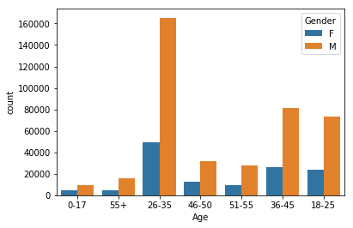

One of the unspoken benefits to Black Friday is all the physical touching involved. If you’re someone who craves human touch and rarely receives any, Black Friday can be a godsend. It’s a very intimate experience where a stranger’s butt can brush your hand, or a stranger’s hand can run its fingers across your lips while trying to pull your head out of the way. I suspect about 20% of attendees are there just to be touched.

But Black Friday isn’t just about shoving people out of your way to see who can spend their money first. Most people come away from Black Friday without any injuries at all. For them it’s a day about coming home with a bunch of stuff they bought and saying “Look at all the stuff I bought!” to whoever will listen. The aforementioned recluses come home and don’t say anything because all they’ve got is themselves.

BEST FEATURE: If you’re ethically flexible, it’s super easy to pickpocket people even if you’re just a beginner.  
WORST FEATURE: Finding blood on the sole of your shoe at an event where someone dies, and not knowing what your involvement may have been because everything was just a blur.

Chapter-4:

DATA COLLECTION:

METHODOLOGY:

A categorical instrument developed by the researchers was divided into three sections: in-line observations prior to the store opening, store entry observations, and individual customer observations. Each instrument also provided an open-ended item for observers to record general consumer comments heard in-line and in the store. Operational definitions were developed by the researchers by adapting previous research by Ekman (1992), Gottman, et al. (1995), and Lee and Dubinsky (2003). After receiving university approval for the instrument, a pilot test was conducted. Nine items were developed for the in-line observation and measured the approximate number of customers waiting for the doors to open, the overall emotions and behaviors exhibited by the customers, the presence and absence of shopping companions, and customer demographics. Cronbach’s alpha, a coefficient of reliability, was computed for the in-line section items. Results revealed an alpha coefficient of .81, indicating that the section had good reliability.

DATA ANALYSIS:

The first step is to import the libraries that we will need in this section:

import pandas as pd

import numpy as np

import matplotlib as pyplot

%matplotlib inline

import seaborn as sns

we need to import our data

data=pd.read_csv(‘BlackFriday.csv’)

data.head()

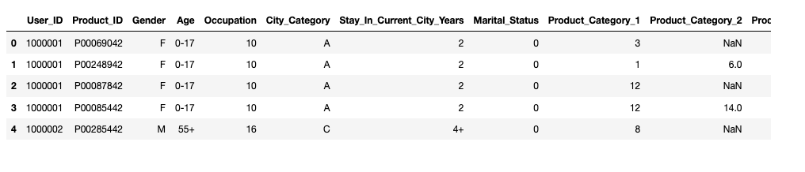

We will use the seaborn library and the countplot function to plot the number of male and female customers.

sns.countplot(data[‘Gender’])

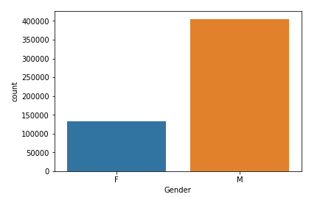

Let's explore the Gender category a bit more. We want to see now distribution of gender variable, but taking into consideration the Age category. Once again countplot function will be used, but now with defined hue parameter.

Sns.countplot(data[‘Age’],hue=data[‘Gender’])

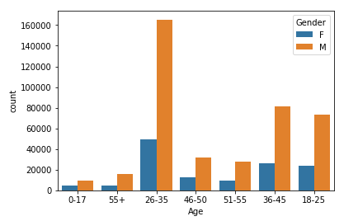

From the figure above, we can easily conclude that the highest number of customers belong to the age group between 26 and 35, for both genders. Younger and older population are far less represented on Black Friday. Based on these results, the retail store should sell most of the products that target people in their late twenties to early thirties. To increase profits, the number of products targeting people around their thirties can be increased while the number of products that target the older or younger population can be reduced.

Next, we will use the describe function to analyze our categories, in terms of mean values, min and max values, standard deviations, etc...

Data.describe()

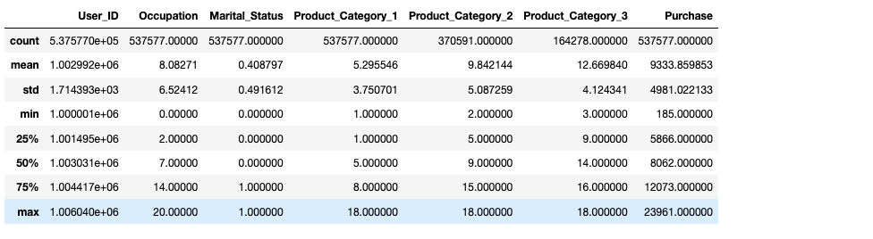

Now, we have information about how much money is spent per occupation category. Let's now graphically plot this information.

import matplotlib.pyplot as plt; plt.rcdefaults()

import matplotlib.pyplot as plt

objects = ('0', '1', '2', '3', '4', '5','6','7','8','9','10', '11','12', '13', '14', '15', '16', '17', '18', '19', '20')

y_pos = np.arange(len(objects))

plt.bar(y_pos, spent_money, align='center', alpha=0.5)

plt.xticks(y_pos, objects)

plt.ylabel('Money spent')

plt.title('Occupation ID')

plt.show()

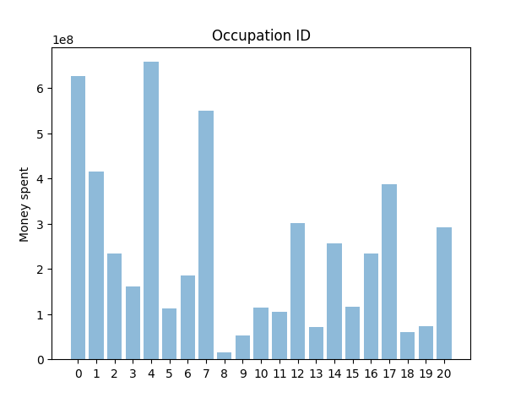

It can be easily observed that people having occupations 0 and 4 spent the most money during Black Friday sales. On the other hand, the people belonging to the occupations with ID 18, 19, and especially occupation 8, have spent the *least* amount of money. It can imply that these groups are the poorest ones, or contrary, the richest people who don't like to shop in that kind of retail stores. We have a deficiency with information to answer that question, and because of that, we would stop here with the analysis of the Occupation category.

City_Category variable is the next one. This category gives us information about cities from which our customers are. First, let's see how many different cities do we have.

explode = (0.1, 0, 0)

fig1, ax1 = plt.subplots(figsize=(11,6))

ax1.pie(data['City_Category'].value_counts(), explode=explode, labels=data['City_Category'].unique(), autopct='%1.1f%%')

plt.legend()

plt.show()

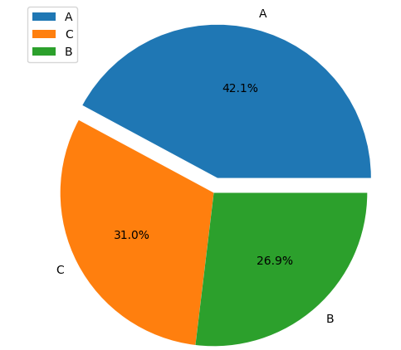

Chapter-5:

CONCLUSION:

Machine learning can be used for a variety of tasks.In this article,we used a Machine Learning algorithm to predict the amount that a customer is likely to spend on black Friday .we also performed exploratory data analysis to find interesting trends from the dataset.For the sake of practice , I will suggest that you try to predict the product that the customer is more likely to purchase, depending upon his gender , age and Occupation.